Tennessee Pharmacist Coalition on Medication Safety
Glucose Management Gap Analysis
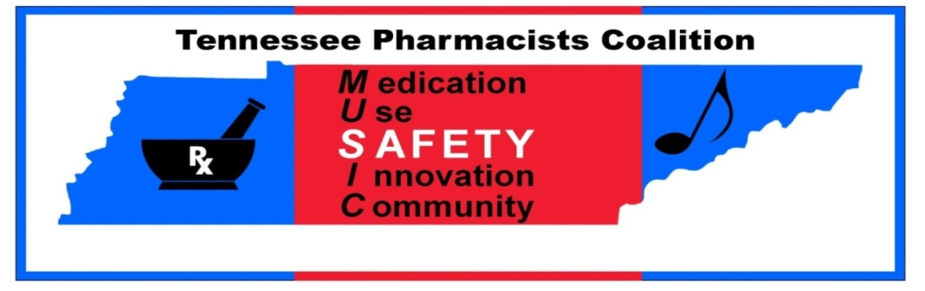
Updated 08/13/2015

Glucose Management Practices
Gap Analysis Questions |  | Yes |  | No |  | If answered “No” – identify the Specific Action plan(s) including persons responsible and timeline to complete.
- The facility has assigned responsibility for coordinating glucose monitoring function (i.e. persons responsible for gathering laboratory data and relaying information to the appropriate staff members)

- The facility has a process in place to ensure necessary information contained in standard glycemic control protocols are consistently populated (manually or automatically) with key information, including at a minimum:
- The patient’s diagnosis
- Allergies
- Most recent pertinent laboratory results
- The facility has standard policies and practices in place for managing the initiation and maintenance of glycemic control therapy which include:
- The specific medication used (e.g., list specific meds)
- The condition being treated
- The potential for drug interactions
- The potential for patient specific interactions
- The facility has a protocol in place to determine the need to adjust anti-hyperglycemic therapy based on key criteria (e.g., blood glucose levels, drug-drug interactions, certain procedures)
- The facility has a protocol in place to determine the need to notify providers when anti-hyperglycemic therapy adjustments are necessary based on key criteria (e.g., blood glucose levels, drug-drug interactions, certain procedures)
  - Addition of a dextrose containing IV fluid to the patient’s regimen
  - Addition or deletion of a anti-hyperglycemic agent to the patient’s regimen
  - Addition, deletion, or adjustment of IV or Oral steroid
  - Change in nutritional status
- The facility has a protocol in place to determine the need to manage hypoglycemic events caused by anti-hyperglycemic therapy based on key criteria
- The facility has a process in place to ensure that anti-hyperglycemic agents are used for the appropriate indication:
- Type 1 Diabetes Mellitus
- Type 2 Diabetes Mellitus
- Stress induced hyperglycemia
- Changes in nutrition status
- Dextrose administration
- Steroid induced hyperglycemia

- The facility has standard policies and practices in place for initiating a glycemic control protocol:
- Diabetic Ketoacidosis protocol
- Hyperglycemia protocol
- Hypoglycemia protocol
- The facility has standard policies and practices in place for initiating additional monitoring:
- Routine blood glucose finger sticks (e.g., before and after meals and at bedtime)
- Routine laboratory serum glucose and creatinine

ADE Prevention and Mitigation Practices for Glucose Management
Gap Analysis Questions |  | Yes |  | No |  | If answered “No” – identify the Specific Action plan(s) including persons responsible and timeline to complete.
- Insulins are included in the organization’s defined list of high alert medications

- A system is in place to alert health care practitioners to significant drug interactions for patients on insulin therapy

- A system is in place to remind the prescriber to evaluate the need for initiating and reinitiating therapy when glycemic agents are being held

- A pharmacy managed system is in place for glycemic agent drug shortage or supply issues which outlines how standard medication safety processes will be followed

- The facility has a process in place to prevent IV insulin orders from being entered into the pharmacy system without including proper assessment of blood glucose levels

- The facility uses smart infusion pumps for the IV administration of insulin with functionality employed to:
- Intercept and prevent wrong dose errors
- Intercept and prevent wrong infusion rate errors

Therapeutic Practices
Gap Analysis Questions |  | Yes |  | No |  | If answered “No” – identify the Specific Action plan(s) including persons responsible and timeline to complete.
- The facility has a process in place, using a standardized tool, to address and document the following prior to initiating anti-hyperglycemic therapy:
- Insulin naïve or insulin tolerant
- Oral anti-hyperglycemic therapy naïve or oral anti-hyperglycemic therapy tolerant
- Recent injury, trauma, surgery, etc.
- Indication for anti-hyperglycemic therapy
(i.e. Type 1 Diabetes or Type 2 Diabetes)
- ADEs experienced while receiving any previous anti-hyperglycemic agent
- Glucose management history
- Drug/drug interactions
- Patient specific interactions
- The facility has a process in place for pharmacists to assist with identification of alternative anti-hyperglycemic agents when contraindications exist
- The indication and therapeutic goal for glucose management therapy is documented in the patient’s medical record and communicated to pharmacy for monitoring and managing patient therapy

- The facility has processes in place for timely access to routine blood glucose monitoring results
- For critical test results reporting, the facility has defined acceptable lengths of time between assessments:
- Blood glucose monitoring assessment
- Treatment of abnormal blood glucose values
- The receipt of results by a health care provider and clinically appropriate anti-hyperglycemic dose changes
Oral Glucose Management Practices
Gap Analysis Questions | Yes |  | No |  | If answered “No” – identify the Specific Action plan(s) including persons responsible and timeline to complete.
- The facility has standard processes in place for initiation of oral anti-hyperglycemic therapy, which include:
- Collection of baseline lab values prior to prescribing oral anti-hyperglycemic agents
- Drug/drug interactions
- History of ADEs to oral anti-hyperglycemic agents
- Recent trauma or surgery
- Administering oral anti-hyperglycemic agents at the same time(s) each day
- Transitioning the patient from one oral anti-hyperglycemic agent to another
- Renal adjustment policy that is individualized for each agent
- Monitoring and/or discontinuing oral anti-hyperglycemic agent therapy
- Management of hypoglycemic events
- Reversal agents are on formulary with policies for appropriate use

Parenteral Glucose Management Practices
Gap Analysis Questions | Yes |  | No |  | If answered “No” – identify the Specific Action plan(s) including persons responsible and timeline to complete.
- The facility has processes in place specific for parenteral insulin therapy
- Safely managing therapy
- Monitoring, discontinuing, and/or reinitiating therapy
- Method to determine therapeutic efficacy
- Standard facility-designed protocol and order sets (P&T approved)

Parenteral Glycemic ADE Prevention and Mitigation Practices
Gap Analysis Questions | Yes |  | No |  | If answered “No” – identify the Specific Action plan(s) including persons responsible and timeline to complete.
- The facility has processes in place to eliminate errors in preparation, storage, and dispensing which includes:
- Utilizing unit dose products
- Limiting concentrations of insulin stored in automated dispensing machines, including U-300 and U-500 availability
- Dispensing individually prepared IV solutions of insulin in limited concentrations
- Dispensing commercially prepared solutions of insulin in limited vial or pen sizes
- Policies and procedures in place for insulin administration, including appropriate syringe use
- Policies and procedures in place if insulin pens are used
- Policies and procedures for home parenteral use products, including GLP-1 agonists (i.e. Bydureon), U-300 and U-500 insulin
- Policies and procedures in place for inpatient use of insulin pumps
- The facility has a process in place to perform an independent double-check for parenteral IV insulin infusions (e.g., with smart pump technology or nurse double-check) with:
- Each new bag given
- Each rate change
- Converting to other forms of insulin therapy (e.g., vials and pens)

Parenteral Glycemic Therapeutic Strategies
Gap Analysis Questions | Yes |  | No |  | If answered “No” – identify the Specific Action plan(s) including persons responsible and timeline to complete.
- The facility has processes in place to initiate and monitor response to therapy including:
- A baseline A1c
- Scheduled blood glucose monitoring
- Laboratory tests with standard intervals for assessment
- Documentation of prior disease and medication history
- Protocol is in place for critically ill medical patients
- Inpatient chart review for drug and/or disease state interactions, including changes in diet or functional status
Critical Thinking and Knowledge Strategies
Gap Analysis Questions | Yes |  | No |  | If answered “No” – identify the Specific Action plan(s) including persons responsible and timeline to complete.
- The facility provides interdisciplinary education on glucose management, which includes:
- Initial training for new hires and existing staff, including protocols and guidelines
- Post-test incorporating a case-study approach to demonstrate proficiency
- Plan for targeting gaps in knowledge
- Ongoing glucose management education is provided to direct care staff when new relevant information is available
Patient Education
Gap Analysis Questions | Yes |  | No |  | If answered “No” – identify the Specific Action plan(s) including persons responsible and timeline to complete.
- When initiating anti-hyperglycemic therapy, patients/caregivers receive verbal and written information on purpose, action, side effects, and monitoring

- The facility has a process in place to educate patients and families on anti-hyperglycemic agents, using teach-back method, to ensure safe therapy including:
- Indication
- Symptoms for monitoring
- Dietary issues
- Drug interactions
- Monitoring requirements
- Duration of therapy
- Potential adverse effects
- Lifestyle modifications
- Sick day protocol
- Altering dosage forms
- Pharmacists are available for consultations to assist with patient education when any health care practitioner identifies a patient who is at risk for non-adherence

Adapted from:
Hypoglycemic Agent Adverse Drug Event Gap Analysis – Component of the Medication Safety Road Map © 2012 Minnesota Hospital Association
Revisions by:
Tennessee Pharmacist Coalition on Medication Safety Best Practices Sub-Committee
©Tennessee Pharmacist Coalition 2015
NOTE: This information, including data and derivative narrative, is proprietary to Tennessee Pharmacist Coalition. It is intended solely for the use of Tennessee Pharmacist Coalition and its members. Such proprietary information may not be used, reproduced, or distributed by any other individual or entity without the express written permission of Tennessee Pharmacist Association by way of the Tennessee Hospital Association.

References:
References:
2013 American Diabetes Association (ADA) Diabetes Management Guidelines

