THA Instructions for Accessing On-line Lactation Education
These are the courses that comprise the 20 hours of online lactation education.
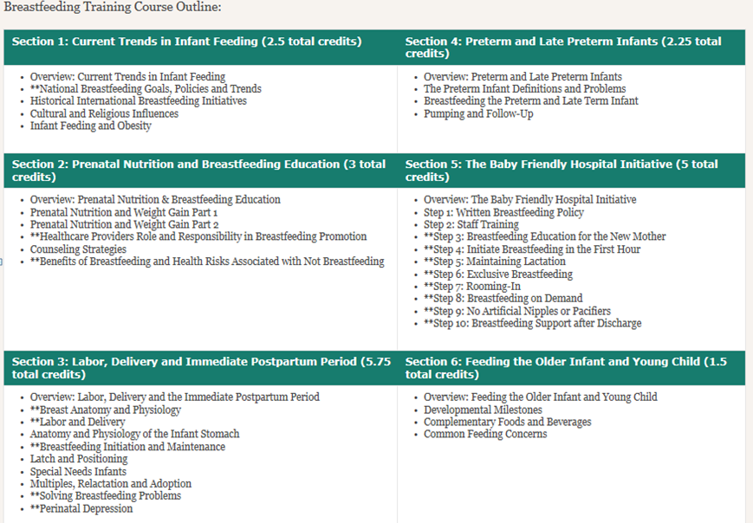

After you submit a list of staff with names, credentials and preferred email address for use with education courses, THA staff will initiate access for your staff members. Each staff member enrolled will receive an email from help@bfconsortium.org that looks like this:
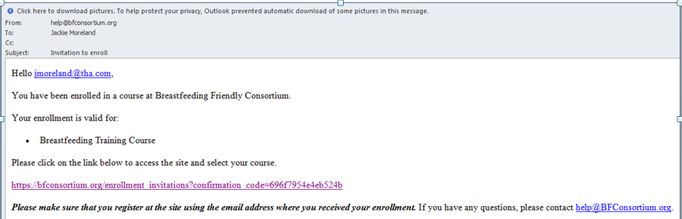

The email will contain a link to the breastfeeding friendly consortium site to register.
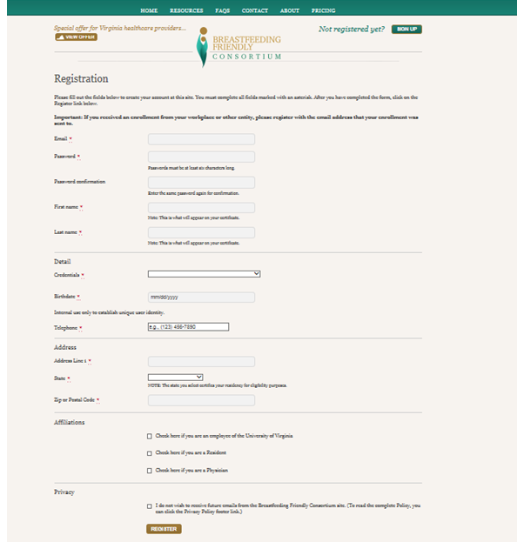

Agree to the terms and conditions page prompt:
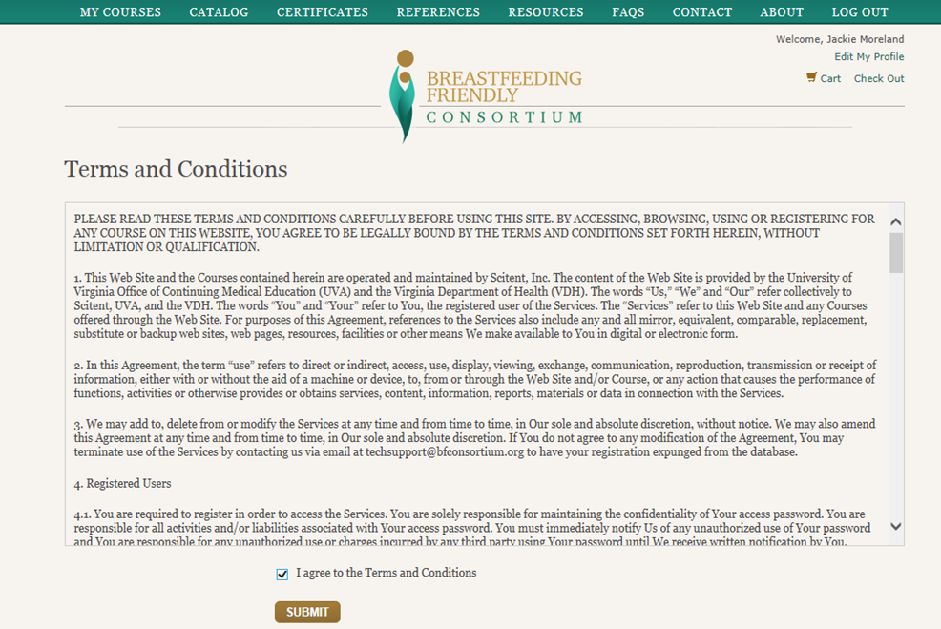

On screen directions lead to the My Courses section and the “ENROLL” button to the Breastfeeding Training Course page
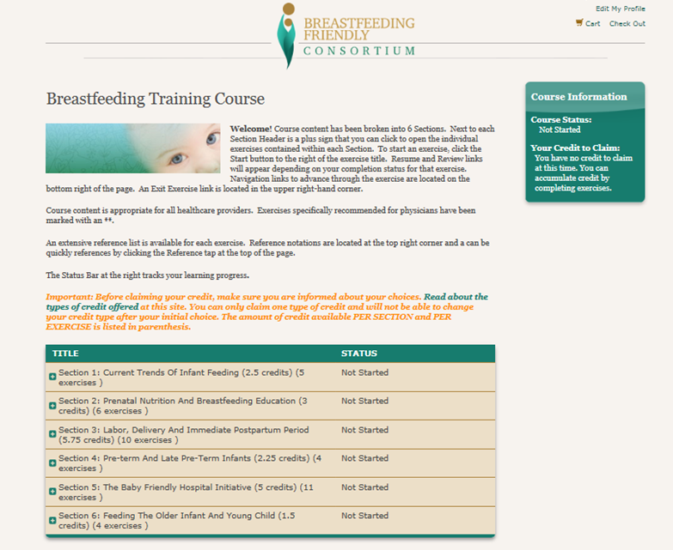
Each staff member will also receive a second email from help@bfconsortium.org verifying their registration and the email address used for registration and to be used to log on
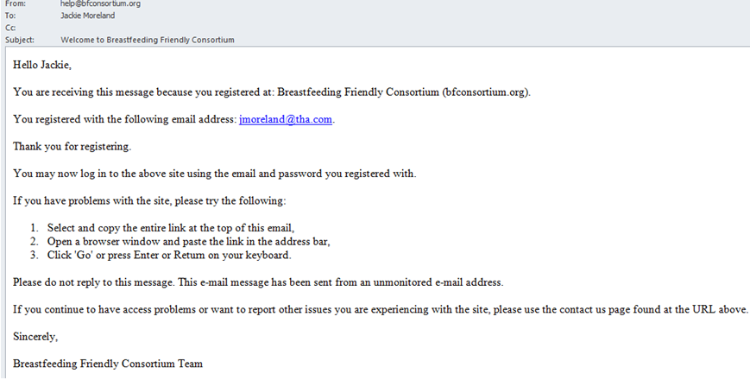

Due to CE requirements, an evaluation is required at the end of each course. After completion, a certificate can be printed:
